**HOSPITAL MANAGEMENT SYSTEM**

21CSC101T

OBJECT ORIENTED DESIGN AND PROGRAMMING

**Mini Project Report**

Submitted by

**Student Name: ANSHUL SHUKLA**

**[Reg. No.: RA2211003010574] B.Tech. CSE-CORE-H1**

**Student Name: SHREYAN DUTTA**

**[Reg. No.: RA2211003010583] B.Tech. CSE-CORE-H1**

***Under the Guidance of***

**Dr. C. MURLIDHARAN**

**Associate Professor, Department of Computing Technologies**



**SCHOOL OF COMPUTING**

**COLLEGE OF ENGINEERING AND TECHNOLOGY**

**SRM INSTITUTE OF SCIENCE AND TECHNOLOGY**

**(Under Section 3 of UGC Act, 1956)**

S.R.M. NAGAR, KATTANKULATHUR – 603 203

KANCHEEPURAM DISTRICT

MAY 2023



**SRM INSTITUTION OF SCIENCE AND TECHNOLOGY KATTANKULATHUR-603203**

**BONAFIDE CERTIFICATE**

This is to certify that 21CSC101T - OBJECT ORIENTED DESIGN AND PROGRAMMING mini project report titled “HOSPITAL MANAGEMENT SYSTEM” is the bonafide work of ANSHUL SHUKLA(RA2211003010574) and

SHREYAN DUTTA(RA2211003010583) who undertook the task of completing the project within the allotted time.

**SIGNATURE SIGNATURE**

Dr. C. Murlidharan Dr.M.Pushpalatha

**OODP – Course Faculty Head of the Department**

Department of Department of

COMPUTING TECHNOLOGIES COMPUTING TECHNOLGIES

**SRMIST SRMIST**

**s**

**TABLE OF CONTENTS**

|  |  |  |
| --- | --- | --- |
| **S.No** | **CONTENTS** | **PAGE NO** |
| 1. | Problem Statement | **4** |
| 2. | Modules of Project | **5** |
| 3. | Diagrams |  |
|  | 1. Use case Diagram | **6** |
|  | 1. Class Diagram | **7** |
|  | 1. Sequence Diagram | **8** |
|  | 1. Collaboration Diagram | **9** |
|  | 1. State Chart Diagram | **10** |
|  | 1. Activity Diagram | **11** |
|  | 1. Package Diagram | **12** |
|  | 1. Component Diagram | **13** |
|  | 1. Deployment Diagram | **14** |
| 4. | Code/Output Screenshots | **15** |
| 5. | Conclusion and Results | **22** |

|  |  |  |
| --- | --- | --- |
| 6. | References | **23** |

**CHAPTER 1**

**1.1PROBLEM STATEMENT**

To create a C++ program on patient management system in hospitals, a.k.a, “Hospital Management System”, to manage data entry of patients admitted in a hospital.The system should also maintain patient records related to bed management, including:

1. Bed number: The unique identifier for each bed in the hospital.
2. Patient name: The name of the patient allocated to a particular bed.
3. Admission date and time: The date and time when the patient was admitted to the hospital.
4. Discharge date and time: The date and time when the patient was discharged from the hospital
5. patient data.

The Hospital Management System should be user-friendly and secure, with appropriate access controls to protect patient data. The system should also be scalable, to accommodate future growth and expansion of the hospital.

**CHAPTER 2**

**MODULES OF PROJECT**

This project contains various modules. All the modules are listed below :-

* **<iostream>:** The <iostream> module is a crucial part of C++ programming, providing essential input and output operations functionality. It includes predefined objects like cin and cout, enabling reading from the standard input and writing to the standard output. This module supports various data types, such as integers, floats, characters, and strings, making it versatile for handling different inputs and outputs. Additionally, <iostream> offers formatting options to control the appearance of output, error-handling objects for displaying error messages, and stream manipulators for modifying the behaviour of input/output streams. Overall, <iostream> simplifies and streamlines the process of interacting with users, displaying information, and handling input/output tasks in C++ programs.
* **<vector>:** Vectors are the same as dynamic arrays with the ability to resize itself automatically when an element is inserted or deleted, with their storage being handled automatically by the container. Vector elements are placed in contiguous storage so that they can be accessed and traversed using iterators. In vectors, data is inserted at the end. Inserting at the end takes differential time, as sometimes the array may need to be extended. Removing the last element takes only constant time because no resizing happens. Inserting and erasing at the beginning or in the middle is linear in time.

**CHAPTER 3**

DIAGRAM

USE CASE DIAGRAM

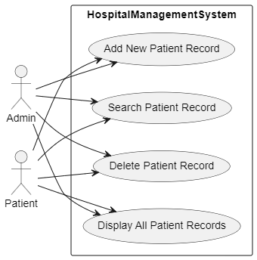

Fig3.1

The use case diagram for the Hospital Management System should show the relationships between the actors and the use cases. The actors can be patients, doctors, hospital staff, and administrators. The use cases should be represented as ovals, and the actors should be represented as stick figures. The relationships between the actors and the use cases can be represented as lines connecting them.

CLASS DIAGRAM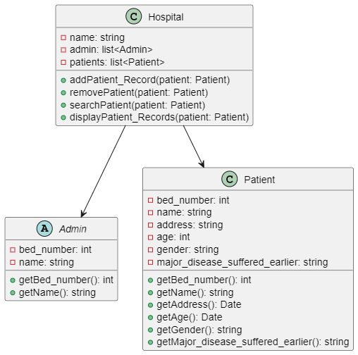

Fig 3.2

The class diagram for the Hospital Management System should show the classes, their attributes and methods, and their relationships. The classes should be represented as rectangles, and the attributes and methods should be listed inside the rectangle. The relationships between the classes should be represented as lines connecting them, with appropriate labels to indicate the relationship type.

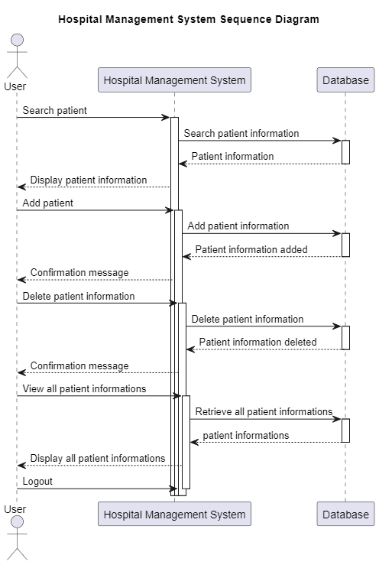

Fig 3.3

COLLABORATION DIAGRAM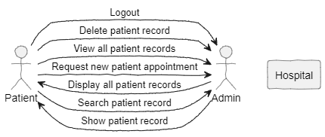

Fig 3.4

STATE CHART DIAGRAM

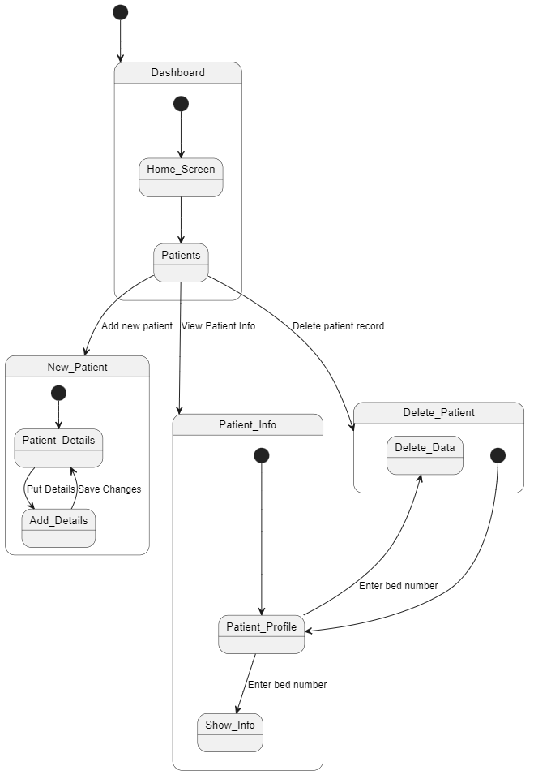

Fig 35

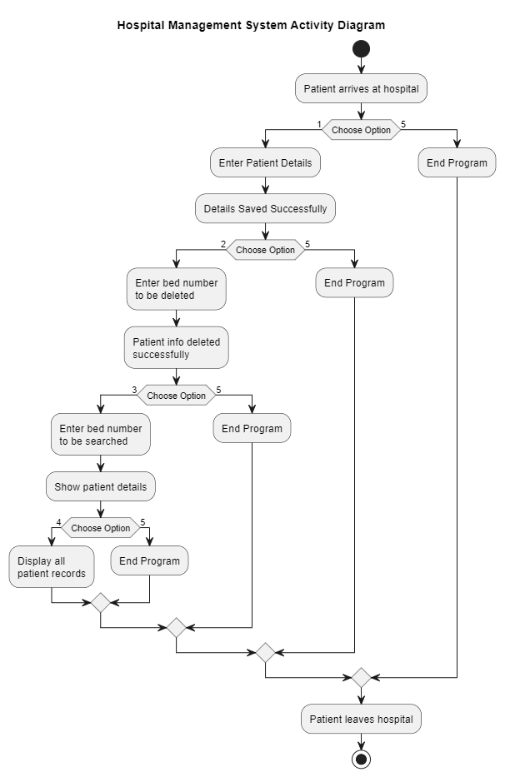

Fig 3.6

PACKAGE DIAGRAM

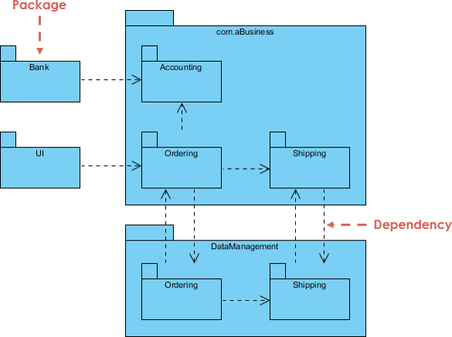

PACKAGE

PATIENT

DETAILS

WEBPAGE OF HOSPITAL MANAGEMENT

PATIENT

PORTAL

ADMIN PORTAL

LOGIN TO WEB PAGE

ADD PATIENT DETAILS

DEPENDENCY

DELETE PATIENT DATA

PATIENT DATA

DISPLAY PATIENT DATA

Fig3.7

COMPONENT DIAGRAM

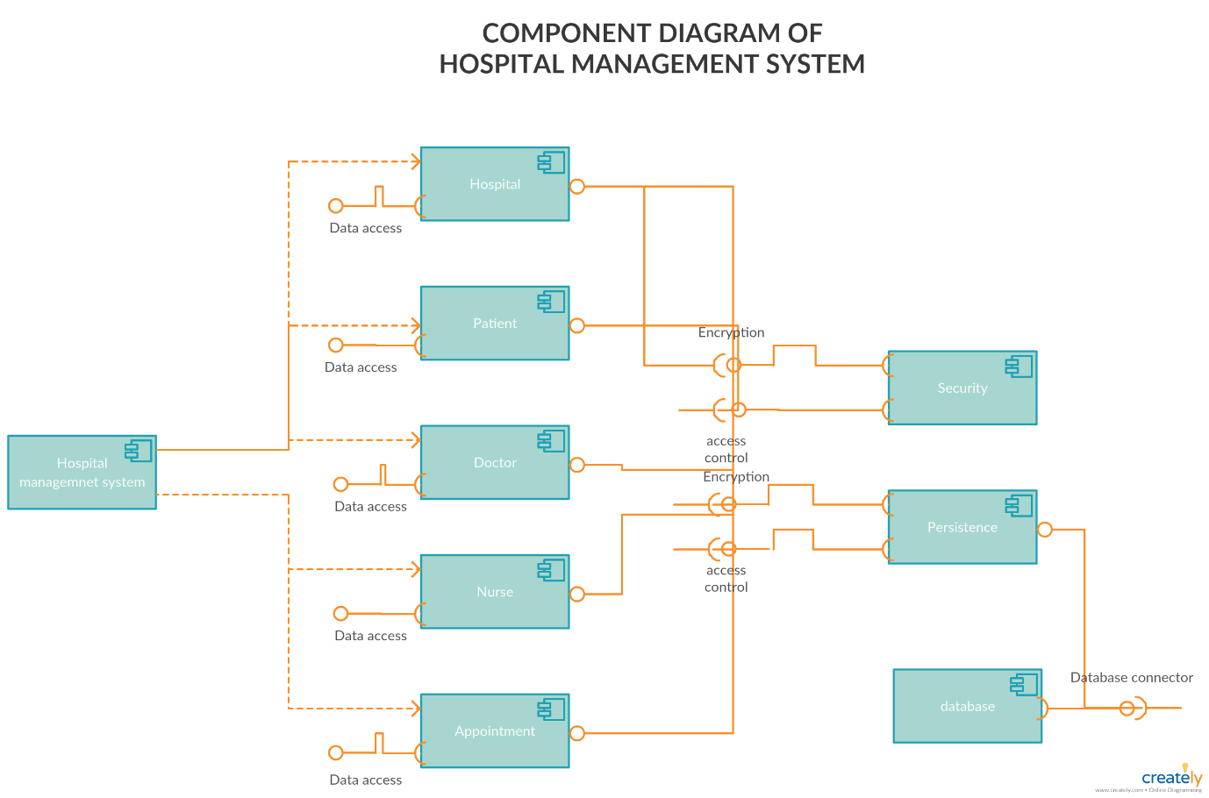

Fig 3.8

DEPLOYMENT DIAGRAM

ADMIN

DATABASE SERVER

HOSPITAL MANAGEMENT SYSTEM

WEB PORTAL

Fig 3.9

**CHAPTER 4**

CODE

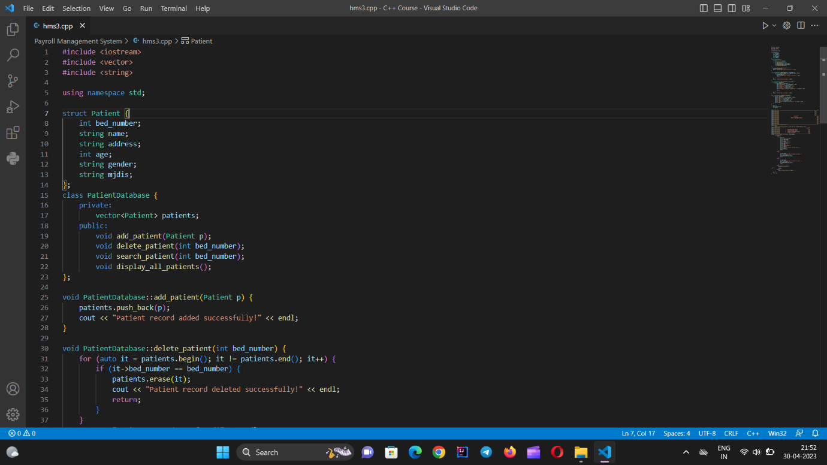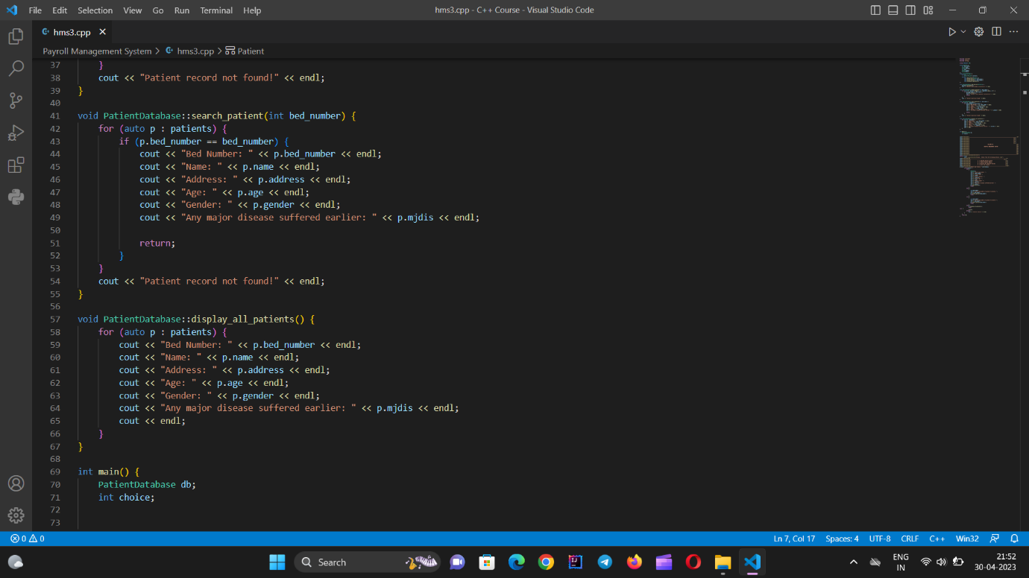

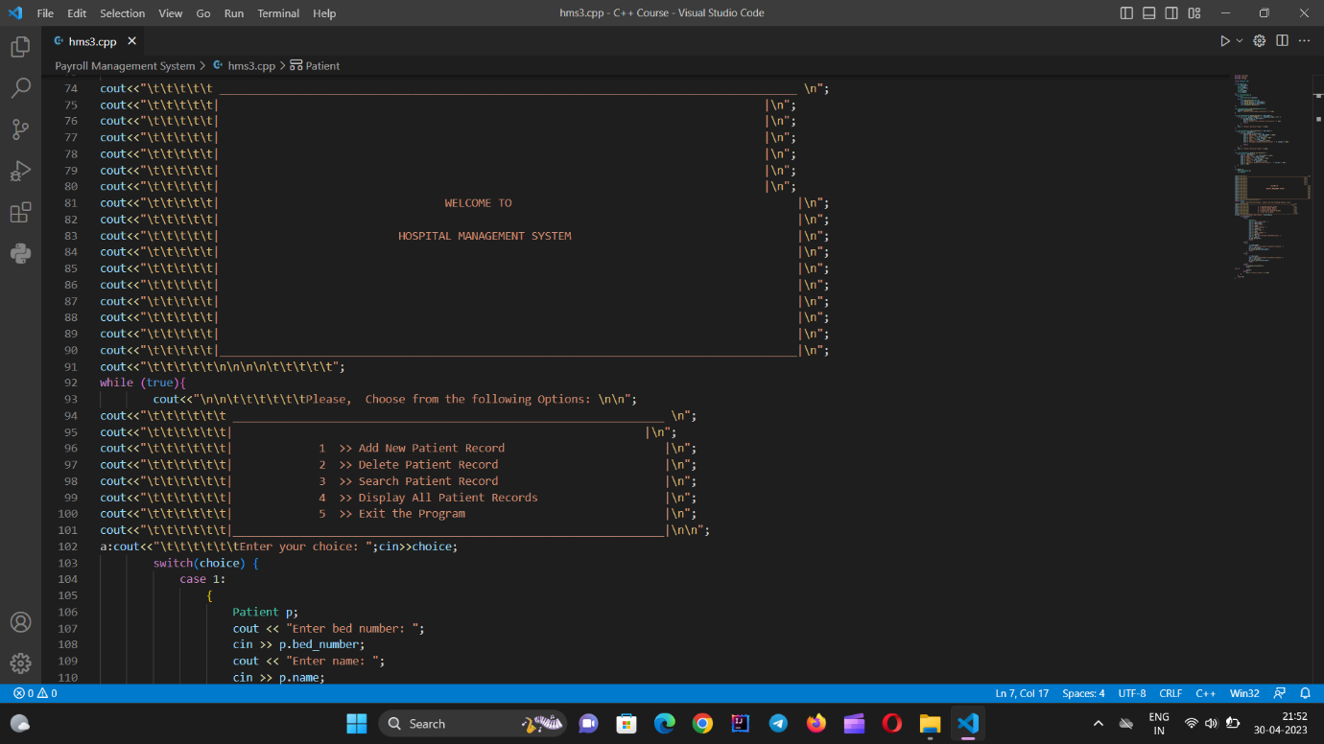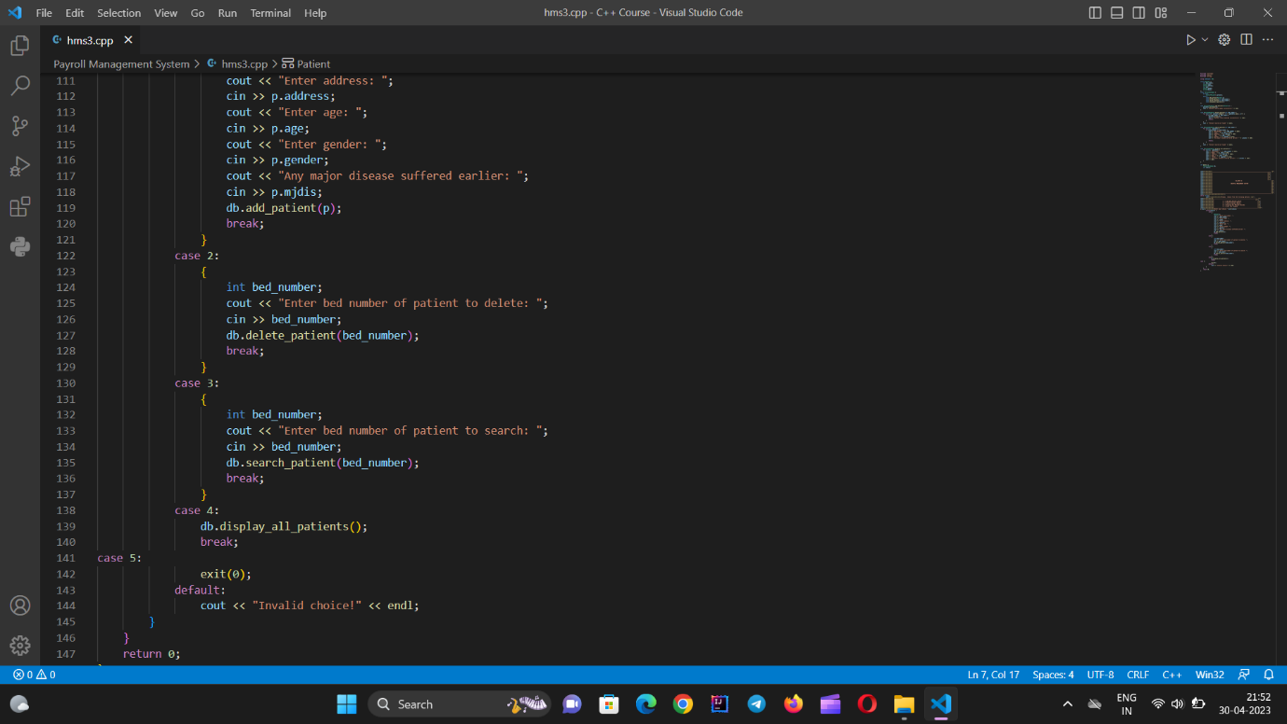

INPUT AND OUTPUT

FOR OPTION 1

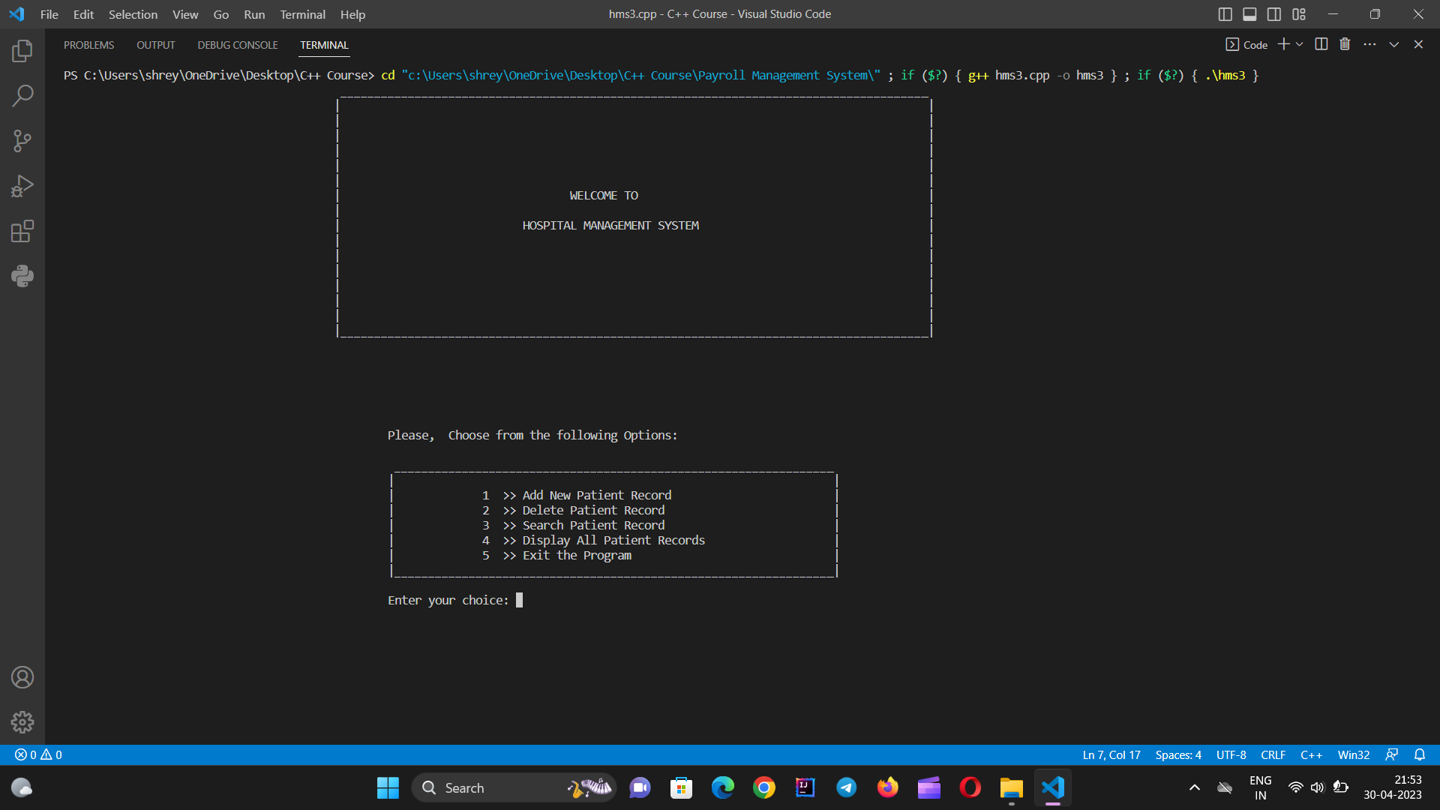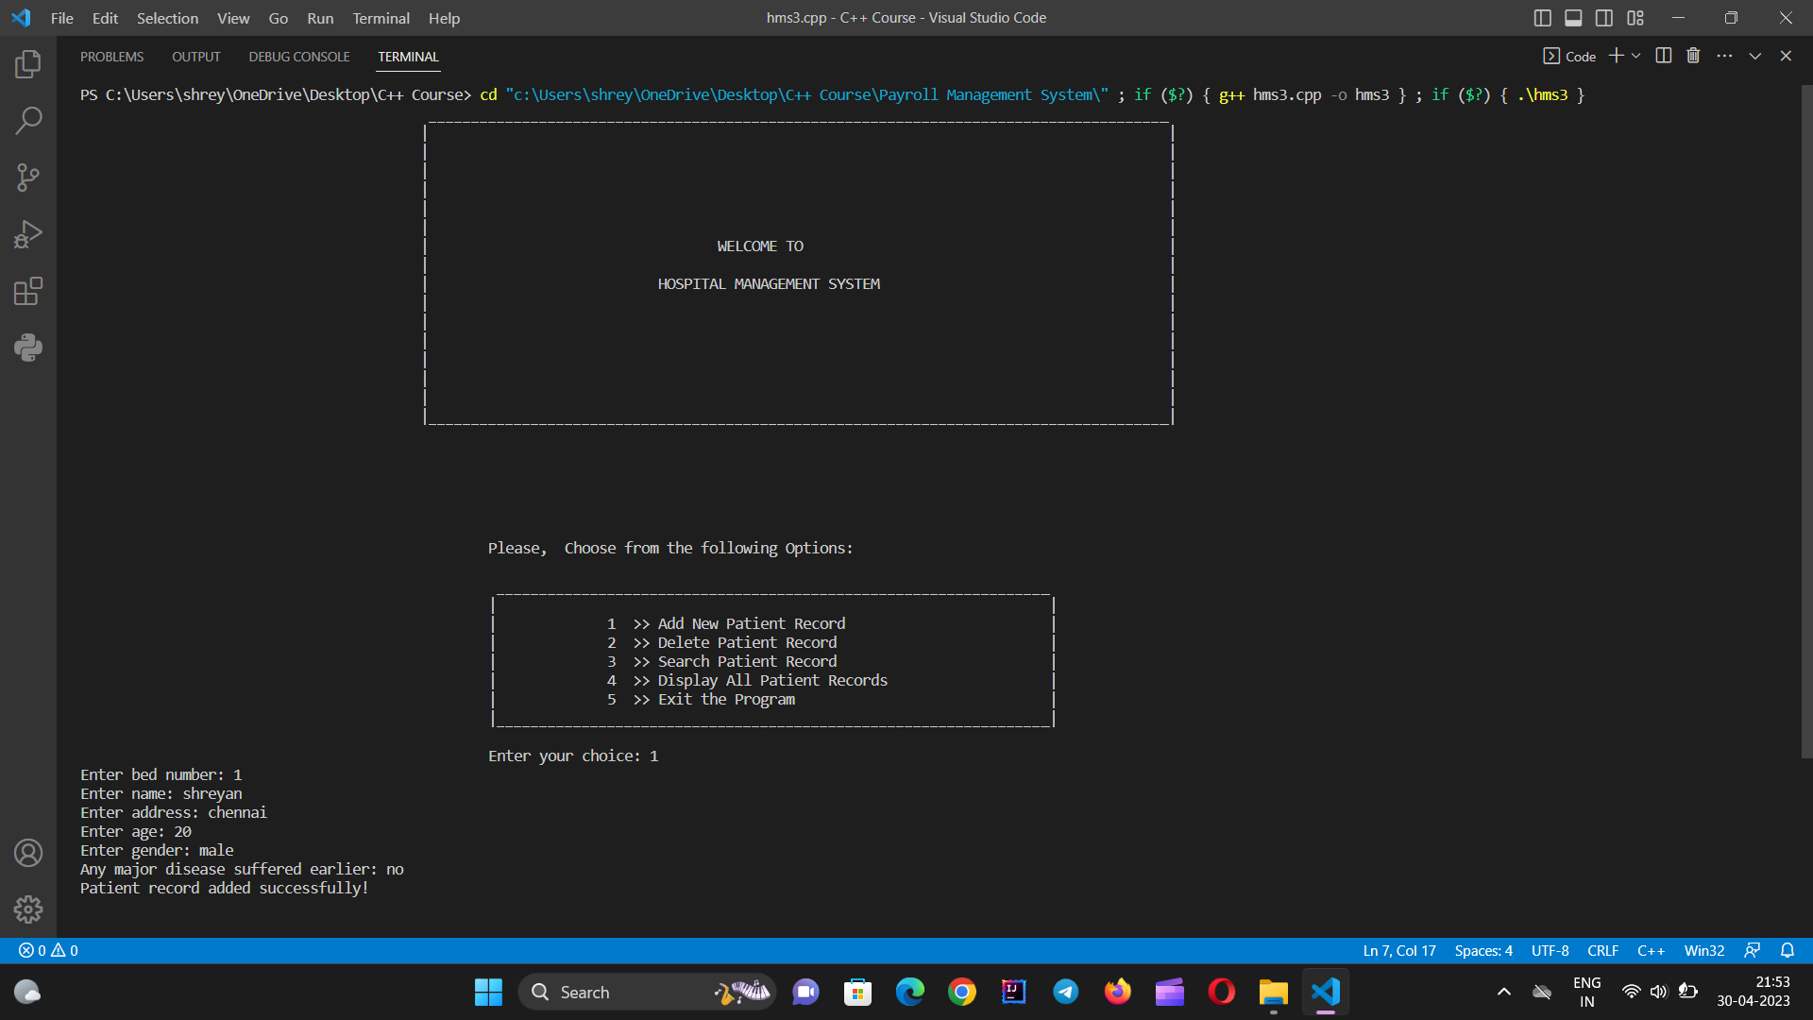

FOR OPTION 2

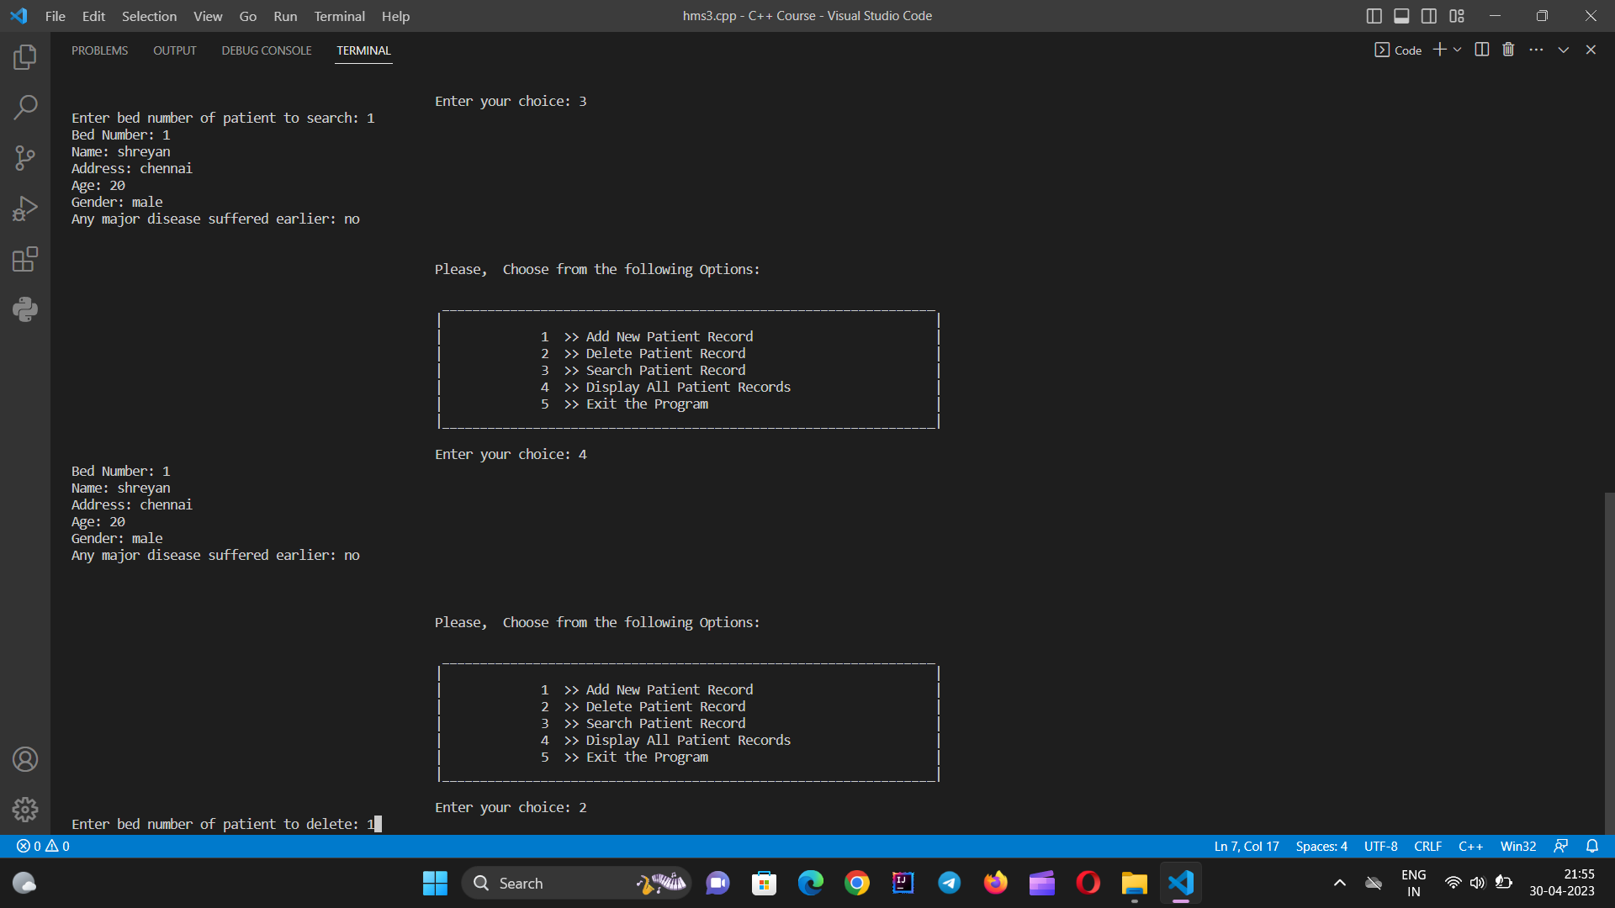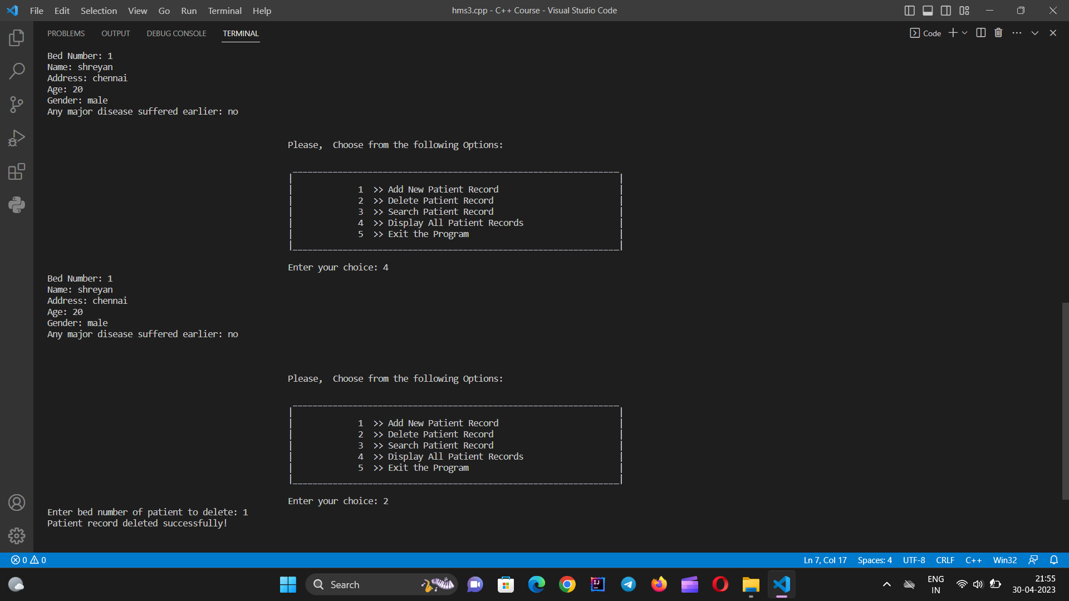

FOR OPTION 3

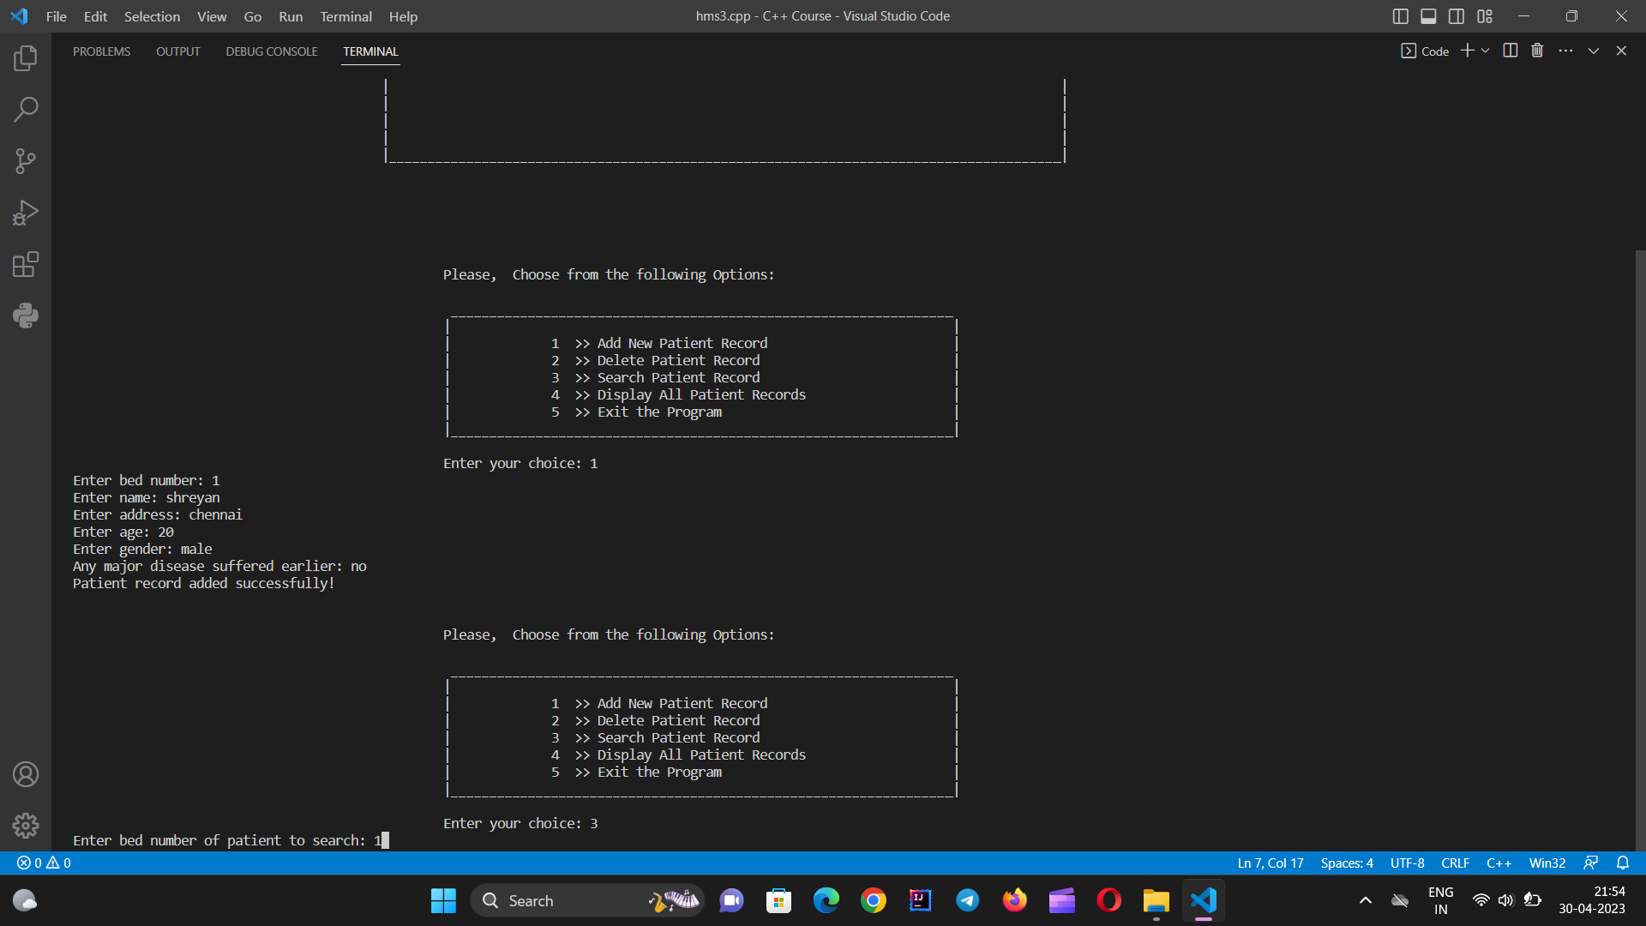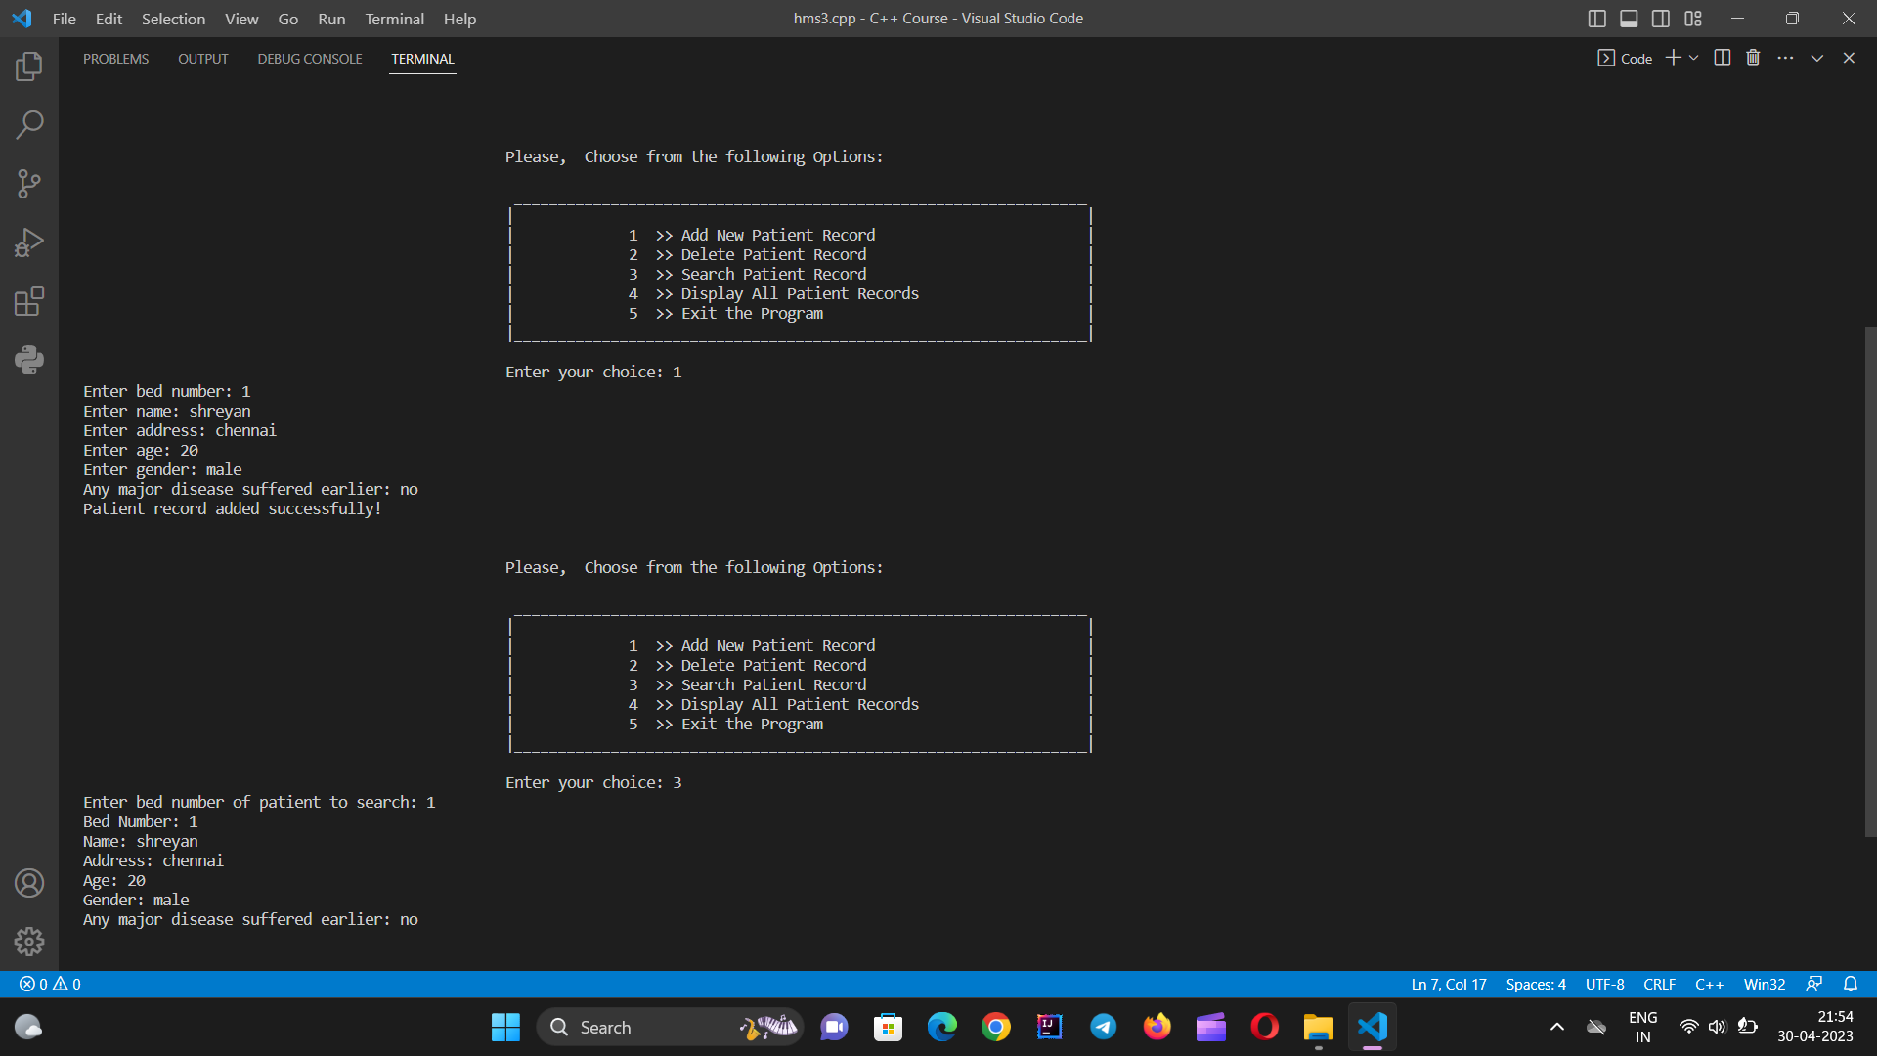

FOR OPTION 4

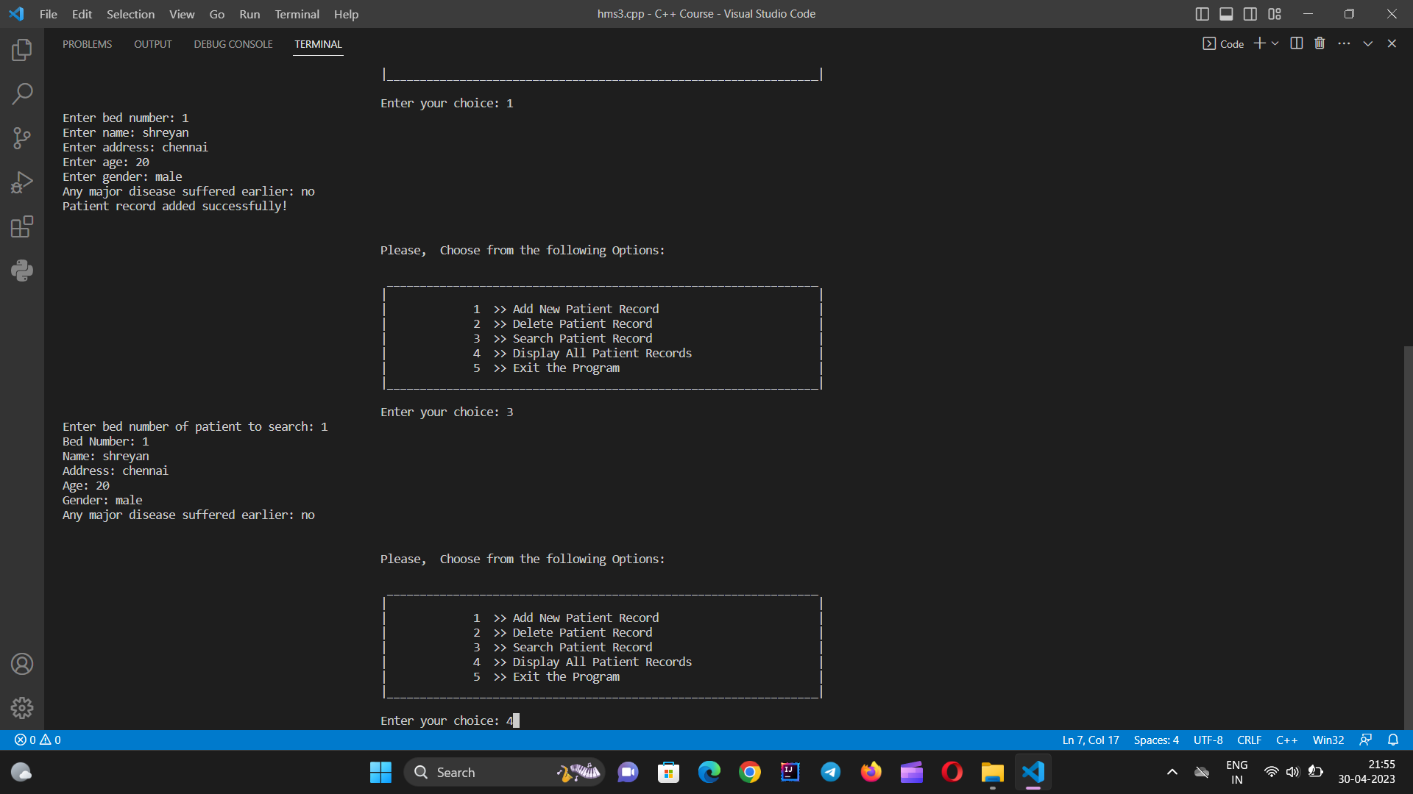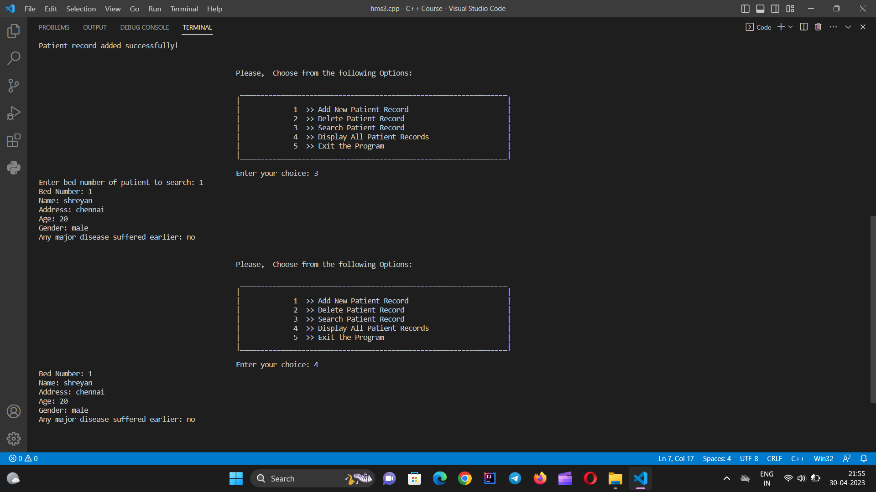

FOR OPTION 5

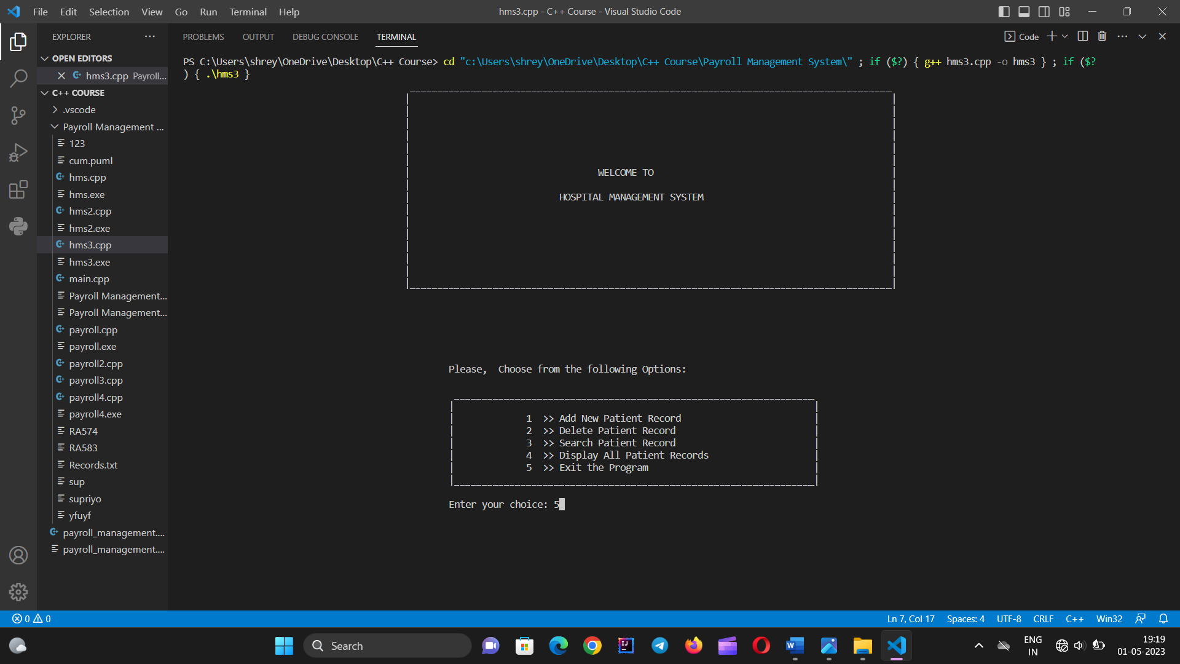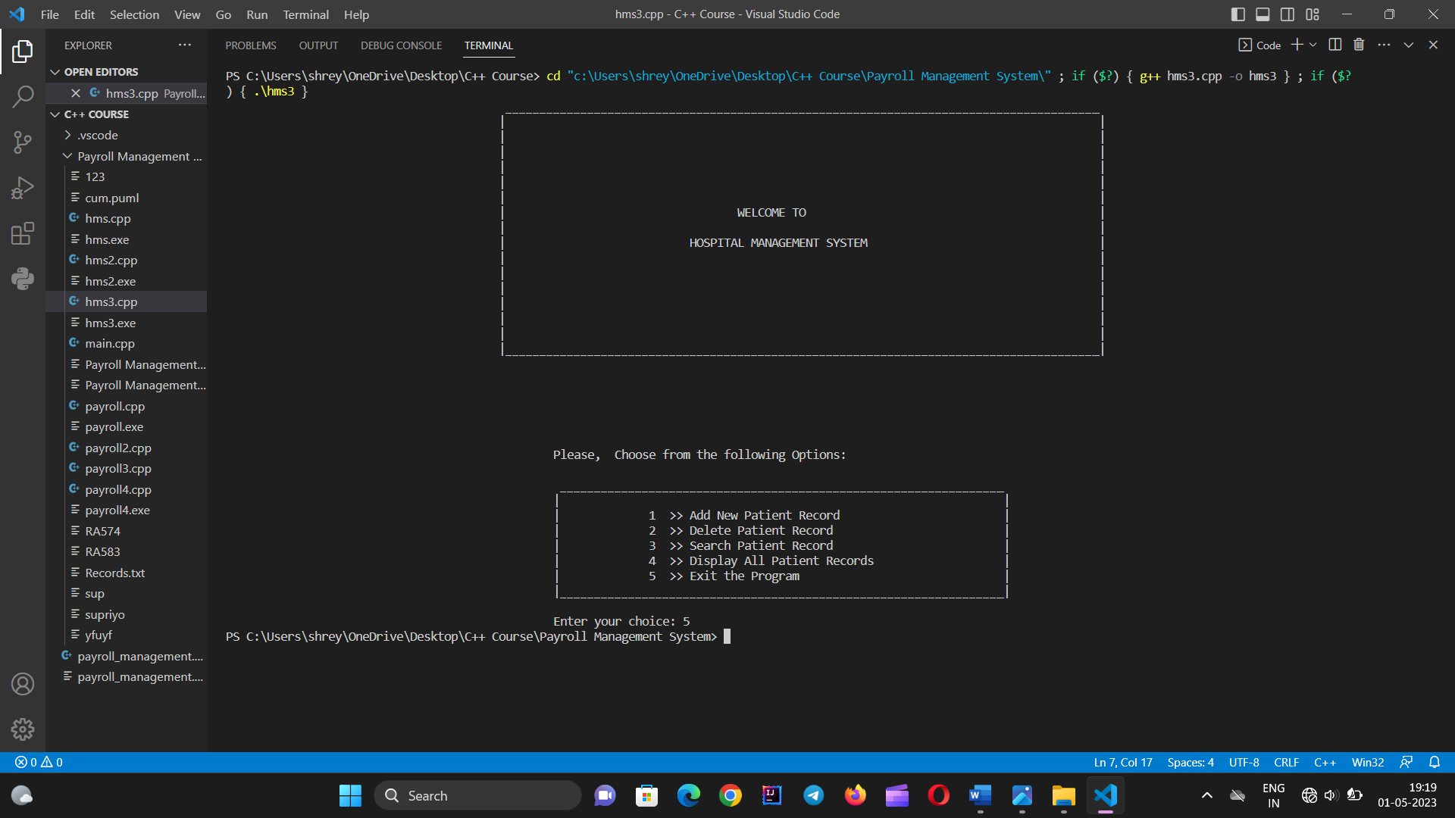

**CHAPTER 5**

**CONCLUSION**

The Hospital Management System Project in C++ can be very helpful for any hospital as this will automate most of the manual tasks. In this project we have added most of the major operations of hospital management like creating a new appointment, checking all appointments, viewing a specific appointment, deleting an existing appointment, etc.

**CHAPTER 6**

**REFERENCE**

●Object oriented programming with C++ by E Balagurusamy

● PPT provided by sir

●GITHUB, GeeksForGeeks, etc.